Users
The process for setting up a new user and allowing access is as follows:

- An admin user sends an invite to the prospective user, see page 2

- Prospective user receives email and follows link, see page 5
- Prospective user completes sign up form to register their account, see page 6

- Prospective user receives email to activate account with link to click, see page 9

- Account is activated, see page 12

- User can log in

Following this the user may forget their password and can reset their password by clicking on the link in the login dialog.

- User completes password reset request form

- User receives an email with a link to reset password

- User completes password reset form with new password

- User can now log in again

User Invitation
To invite a new user an administrator user must already be logged in. The admin user will have access to the Admin ⇒ Settings screen. On this screen you will see a list of users:

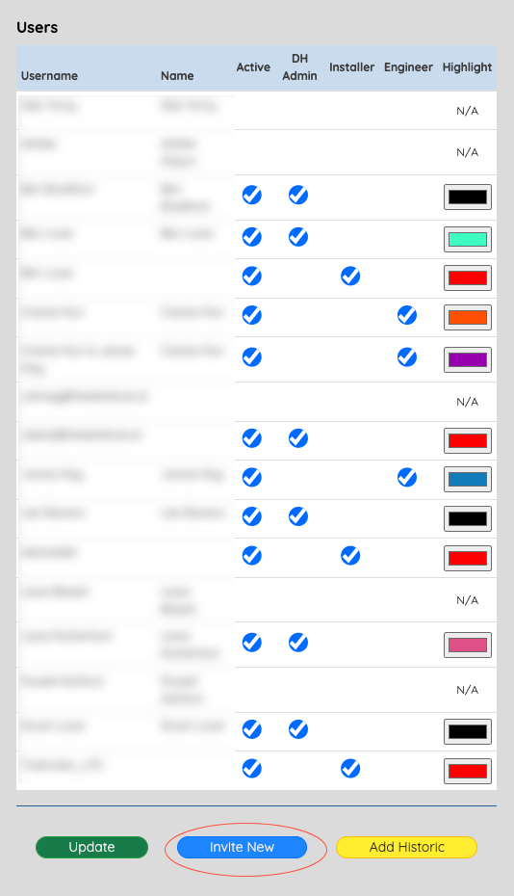

The blue ‘Invite New’ button has an id = 'inviteNewUser' and is defined in globalsettings.php.

The click event is listened for in clickEvents.js and the following jQuery listener shows the registration modal dialog.

$(document).on("click", "#inviteNewUser", function (event) {
event.preventDefault();
$("#modalGetNewUserEmail").modal("show");
});

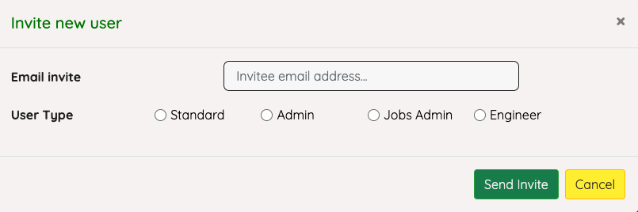

The modal dialog to show the new user invite above is in php/modal_UserEmail_get.php

The yellow cancel button will just dismiss the dialog, the green ‘Send Invite’, id= ‘inviteNewUserEmail’, button is listened to by the following jQuery which sends information from the dialog to be checked and, if all is complete, to send an email to invite the new user.

$(document).on("click", "#inviteNewUserEmail", function (event) {
event.preventDefault(); // prevent button default action

// create an array dataToPost and populate with the email address
entered and the checked status of the four buttons //
dataToPost = {};
dataToPost.newUserEmail = $("#newUserEmailAddress").val();
dataToPost.userTypeStandard = $("#userLogInStandard:checked").val();
dataToPost.userTypeAdmin = $("#userLogInAdmin:checked").val();
dataToPost.userTypeInstaller = $("#userLogInInstaller:checked").val();
dataToPost.userTypeEngineer = $("#userLogInEngineer:checked").val();

// send an ajax request to validate user input, send invite email and
return a success or failed message to the user //
$.ajax({
url: "inviteNewUser.php",
type: "POST",
data: dataToPost,
success: function (data) {
if (data.includes("An invitation email has been sent to")) {
$("#modalGetNewUserEmail").modal("hide");
$("#userErrorBox").html(data);
$("#userErrorBox").delay(2500).hide(0);
} else {
$("#newUserEmailMessage").html(data);
}
},
error: function () {},
});
});

The AJAX request will return 'data’ to the success function. If the request returns a positive result, the modal dialog is hidden and a message confirming to the user that an email has been sent to them. If the request returns a negative result, the dialog stays open, and the user is shown an error message.

The AJAX request is to ‘inviteNewUser.php’

Invitation to new user

<?php
session_start();
include 'connect.php';

$missingEmail = '<p>Please enter your email address.</p>';
$invalidEmail = '<p>You must enter a valid email address to register.</p>';
$missingLogInType = '<p>You must select the type of user.</p>';
$errors = "";

// Check email address exists and check if it is a valid format
if (empty($_POST['newUserEmail'])) {
$errors .= $missingEmail;
} else {
$userEmail = filter_var($_POST['newUserEmail'], FILTER_SANITIZE_EMAIL);
if (!filter_var($userEmail, FILTER_VALIDATE_EMAIL)) {
$errors .= $invalidEmail;
}
}

// Check which radio button is ‘on’
$logInMask = 0;
if ($_POST['userTypeAdmin'] == 'on') {
$logInMask = 1;
} else if ($_POST['userTypeStandard'] == 'on') {
$logInMask = 2;
} else if ($_POST['userTypeInstaller'] == 'on') {
$logInMask = 3;
} else if ($_POST['userTypeEngineer'] == 'on') {
$logInMask = 4;
}
if ($logInMask == 0) {
$errors .= $missingLogInType;
}

// Are there any errors, if so, return a message to the user and exit
if ($errors) {
$resultMessage = "<div class='alert alert-danger alert-style'>" . $errors . "</div";
echo $resultMessage;
exit();
}

// If there are no errors
$userEmail = mysqli_real_escape_string($link, $userEmail);

// Check database to see if email is already in use
$sql = "SELECT * FROM tblUsers WHERE email = '$userEmail'";
$result = mysqli_query($link, $sql);
if (!$result) {
echo '<div class="alert alert-danger">TDH Manager database is not currently available.</div>';
echo '<div class="alert alert-danger">' . mysqli_error($link) . '</div>';
exit();
}
if (mysqli_num_rows($result)) {
echo '<div class="alert alert-danger">' . $userEmail . ' has already been registered.</div>';
exit();
}

// create a unique activation key and store in the database
$activationKey = bin2hex(openssl_random_pseudo_bytes(16));
$sql = "INSERT INTO tblInvites (email, activationKey, logInType) VALUES ('$userEmail', '$activationKey', '$logInMask')";
$result = mysqli_query($link, $sql);

if (!$result) {
echo '<div class="alert alert-danger">Could not update the database.</div>';
echo '<div class="alert alert-danger">' . mysqli_error($link) . '</div>';
exit();
}

// send user an email with a registration link, which includes the activation key
// We use a third party library to send the email
require_once 'mailer/SMTP.php';
require_once 'mailer/PHPMailer.php';
require_once 'mailer/Exception.php';

use \PHPMailer\PHPMailer\Exception;
use \PHPMailer\PHPMailer\PHPMailer;

$mail = new PHPMailer(true); // Passing `true` enables exceptions
try {
//settings
$mail->SMTPDebug = 0; // Enable verbose debug output
$mail->isSMTP(); // Set mailer to use SMTP
$mail->Host = 'send.one.com';
$mail->SMTPAuth = true; // Enable SMTP authentication
$mail->Username = 'accounts@thedatahub.uk'; // SMTP username
$mail->Password = '.b.;p}2,F4paaa!u'; // SMTP password
$mail->SMTPSecure = 'ssl';
$mail->Port = 465;

$mail->setFrom('accounts@thedatahub.uk', 'TDH Manager'); // sender
$mail->addAddress($userEmail, $userEmail); // Add a recipient
$mail->isHTML(true); // Set email format to HTML
$mail->Subject = 'TDH Manager - Invitation to Register'; // subject
$mail->Body = "<html><head></head><body><h2 style='color: blue'>TDH Manager.</h2><br><br>You have been invited to register a user account for TDH Manager. Click on the link below to register your account<br><br> https://tdhmanager.azurewebsites.net/signup.php?email=" . urlencode($userEmail) . "&activationKey=$activationKey</body></html>";
$mail->AltBody = "You have been invited to register a user account for TDH Manager.\n\nClick on the link below to register your account.\n\n https://tdhmanager.azurewebsites.net/signup.php?email=" . urlencode($userEmail) . "&activationKey=$activationKey</body></html>"; // email body
$mail->send(); // send the email

echo "<div class='alert alert-success'>An invitation email has been sent to $userEmail.</div>"; // return a success message
} catch (Exception $e) {
echo 'Message could not be sent.'; // or send an error message
echo 'Mailer Error: ' . $mail->ErrorInfo;
}

// Insert an item into the database to log the new user invite
$sql = "INSERT INTO tblEventLog (Description, UserID) VALUES ('New user invited - $userEmail', '" . $_SESSION['userID'] . "')";
$result = mysqli_query($link, $sql);

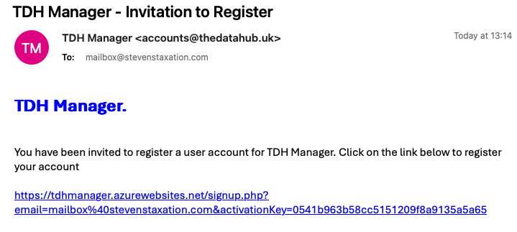
The email sent will include a link to which will direct the user to the signup page 'signup.php’, which includes email and activation key to identify the user.

User sign up
When a user clicks the link in the ‘Invitation to Register’ email, they are redirected to ‘signup.php’ and there is POST data in the link, consisting of the registered email address and an activation key.

<?php
session_start();
include "connect.php";

//check if user and activation key are present and correct
$logInType = "";
if (isset($_GET['email']) && isset($_GET['activationKey'])) {
$sql = "SELECT * FROM tblInvites WHERE email='" . $_GET['email'] . "' AND activationKey='" . $_GET['activationKey'] . "'";
$result = mysqli_query($link, $sql);

// there can only be one combination of email and activation key, so if the
query does not return exactly 1 result then do not allow user to continue.
if (!$result || mysqli_num_rows($result)!=1) {
echo "You are not authorised to access this page";
exit();
}

$row = mysqli_fetch_array($result);
$logInType = $row['loginType'];

// invite can only be used once and so delete it now it has been used
$sql = "DELETE FROM tblInvites WHERE email='" . $_GET['email'] . "' AND activationKey='" . $_GET['activationKey'] . "'";

} else {
// if an incorrect link is used then do not allow user to continue
echo "You are not authorised to access this page";
exit();
}

?>

// create a HTML page to capture the user’s sign up details
<!DOCTYPE HTML>
<HTML lang="en">

<HEAD>
<meta charset="UTF-8">
<meta name="viewport" content="width=device-width, initial-scale=1, shrink-to-
fit=no" description content="Book library database">

<!-- bootstrap -->
// Bootstrap links here – removed from this page for brevity

<!-- Font Awesome 5 Icons-->
// Font Awesome links here – removed for brevity

<!-- Font -->
// Google fonts link, removed from page for brevity

<!-- standard style sheets -->
<link rel="stylesheet" type="text/css" href="styles/styles.css">
<title>TDH Manager</title>
</HEAD>

<BODY>
<div class='main'>
<section class='signUp'>
<div class='container'>
<div class='signUpContent'>
<form method = 'POST' id = 'signUpForm' class='signUpForm'>
<img src='images/logo_swirl.png'>
<h2 class='form-header text-center' style='color: #0078bd; float: right; margin-top: 17px;'>
<strong>TDH Manager</strong>
</h2>
<h3 class='form-title h4' style='text-align: center; margin-top: 8px; margin-bottom: 30px;'>Create an account</h3>
<div id='registerMessage'></div>
<div class='form-group'>
<input type='text' class='form-input' name='userEmail'
readonly='readonly' id='userEmail' value='<?php echo
$_GET['email']?>'>
</div>

<div class='form-group'>
<input type='text' class='form-input' name='userName' id='userName'
placeholder='Enter a user name...' autocomplete='username'
autofocus>
</div>

<div class='form-group'>
<input type='password' class='form-input' name='password'
id='password' placeholder='Create a password...'
autocomplete='new-password'>
<span toggle='#password'></span>
</div>

<div class='form-group'>
<input type='password' class='form-input' name='password2'
id='password2' placeholder='Confirm your password...'
autocomplete='new-password'>
</div>

<div class='form-group'>
<div id='hiddenUserType' style='display:none'><?php echo
$logInType?>
</div>
</div>

<div class='form-group text-center'>
<button type='submit' name='submit' id='submit' class='form-submit
btn btn-success' style='border-radius: 10px;'>
Register Account
</button>
</div>

</form>
<p class='logInInstead text-center'>
<small>Already Registered? Then <a href='index.php' class =
'logMeInLink'>
log in here</a>
</small>
</p>
</div>
</div>
</section>
</div>
<script src='scripts/index.js'></script>
</BODY>
</HTML>
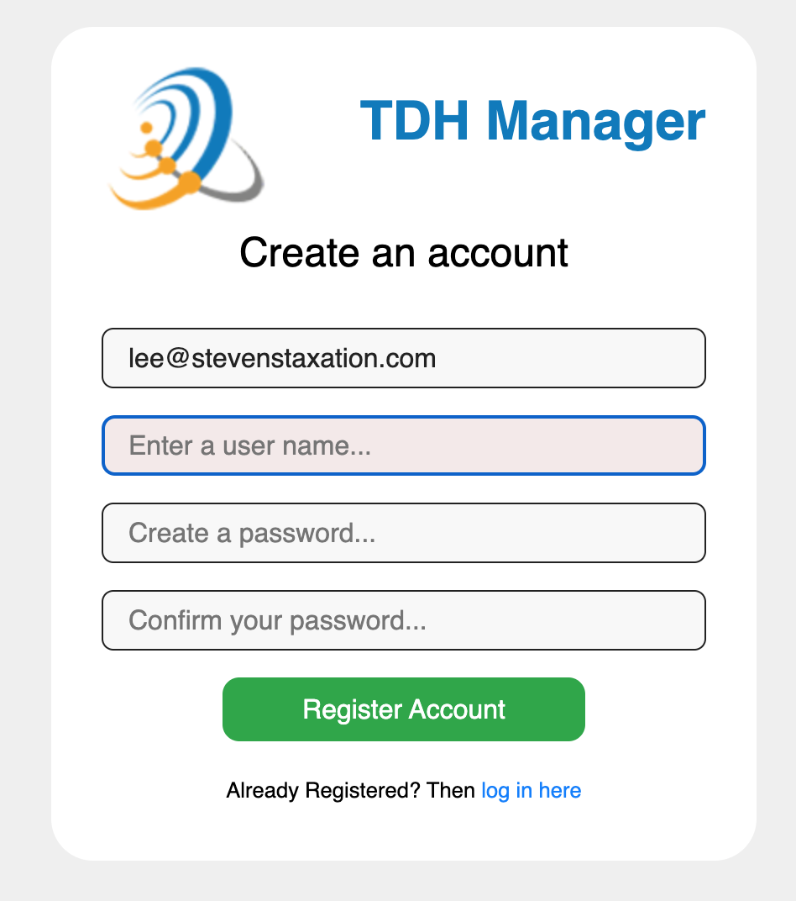

When redirected the user is given the opportunity to create an account by entering a username and password, they will also need to confirm their password.

On this screen there is a link to return to the login page, this is a simple <a href> link back to the index.php page.

If the user chooses to create an account and clicks the green Register Account button the form is submitted by the following JQuery event listener in index.js for checking and to add the user to the database:

Request to activate account

// AJAX call for the SIGN UP form
// once the form is submitted

$('#signUpForm').submit(function (event) {
"use strict";
// prevent default PHP processing
event.preventDefault();
// collect user inputs
var dataToPost = $(this).serializeArray();
// send to register.php using AJAX
dataToPost.push({
name: 'logInType',
value: $('#hiddenUserType').html()
});

$.ajax({
url: "register.php",
type: "POST",
data: dataToPost,
success: function (data) {
if (data) {
$('#registerMessage').html(data);
if (data.includes("success")) {
window.setTimeout(function () {
window.location.href = "index.php";
}, 4000);
}
}
},
error: function () {
$('#registerMessage').html("<div class='alert alert-danger'>TDH Manager is not available at the moment. Contact your administrator.</div>");
}

});

});

Thia script sends the user’s input from the create account form to register.php.

<?php
session_start();
include 'connect.php';

// Check user's input
// Possible errors include
$missingEmail = '<p><strong>Please enter your email address.</strong></p>';
$missingUserName = '<p><strong>Please enter a user name.</strong></p>';
$invalidEmail = '<p><strong>You must enter a valid email address to register.</strong></p>';
$missingPassword = '<p><strong>Please enter a password</strong></p>';
$invalidPassword = '<p><strong>Your password does not meet the minimum security requirements. Your password should be at least 8 characters long and include at least one capital letter and one number.</strong></p>';
$differentPassword = '<p><strong>Your passwords do not match.</strong></p>';
$missingPassword2 = '<p><strong>Please confirm your password.</strong></p>';
$errors = "";

// Get the user's input and check for errors
// Email address
if (empty($_POST['userEmail'])) {
$errors .= $missingEmail;
} else {
$userEmail = filter_var($_POST['userEmail'], FILTER_SANITIZE_EMAIL);
if (!filter_var($userEmail, FILTER_VALIDATE_EMAIL)) {
$errors .= $invalidEmail;
}
}
if (empty($_POST['userName'])) {
$errors .= $missingUserName;
} else {
$userName = filter_var($_POST['userName'], FILTER_SANITIZE_STRING);
}

// password
if (empty($_POST['password'])) {
$errors .= $missingPassword;
} elseif (!(strlen($_POST['password']) >= 8 and preg_match('/[A-Z]/', $_POST['password']) and preg_match('/[0-9]/', $_POST['password']))) {
$errors .= $invalidPassword;
} else {
$password = filter_var($_POST['password'], FILTER_SANITIZE_STRING);
if (empty($_POST['password2'])) {
$errors .= $missingPassword2;
} else {
$password2 = filter_var($_POST['password2'], FILTER_SANITIZE_STRING);
if ($password !== $password2) {
$errors .= $differentPassword;
}
}
}

// login Type
$userType = $_POST['logInType'];
$userIsAdmin = 0;
$userIsInstaller = 0;
$userIsEngineer = 0;

switch ($userType) {
case '1':
$userIsAdmin = 1;
break;
case '3':
$userIsInstaller = 1;
break;
case '4':
$userIsEngineer = 1;
break;
default:
break;
}

// Are there any errors?
if ($errors) {
$resultMessage = "<div class='alart alert-danger alert-style'>" . $errors . "</div";
echo $resultMessage;
exit();
}

// No errors
$userEmail = mysqli_real_escape_string($link, $userEmail);
$userName = mysqli_real_escape_string($link, $userName);
$password = mysqli_real_escape_string($link, $password);
$password = hash('sha256', $password);

// does email already exist?
$sql = "SELECT * FROM tblUsers WHERE email = '$userEmail'";
$result = mysqli_query($link, $sql);
if (!$result) {
echo '<div class="alert alert-danger">TDH Manager database is not currently available.</div>';
echo '<div class="alert alert-danger">' . mysqli_error($link) . '</div>';
exit();
}
if (mysqli_num_rows($result)) {
echo '<div class="alert alert-danger">That email address has already been registered. Do you want to <a href="logIn.php">log in</a>?</div>';
exit();
}

// create a unique activation
$activationKey = bin2hex(openssl_random_pseudo_bytes(16));
$sql = "INSERT INTO tblUsers (email, userName, password, activation, isAdmin, isInstaller, isEngineer) VALUES ('$userEmail', '$userName', '$password', '$activationKey', '$userIsAdmin', '$userIsInstaller', '$userIsEngineer')";
$result = mysqli_query($link, $sql);

if (!$result) {
echo '<div class="alert alert-danger">Could not update the database.</div>';
echo '<div class="alert alert-danger">' . mysqli_error($link) . '</div>';
exit();
}

$newUserID = $link->insert_id;
$sql = "INSERT INTO tblUserRecord (userID) VALUES('$newUserID')";
$result = mysqli_query($link, $sql);
if (!$result) {
echo '<div class="alert alert-danger">Could not update the database.</div>';
echo '<div class="alert alert-danger">' . mysqli_error($link) . '</div>';
exit();
}

// send user an email with an activation link
require_once 'mailer/SMTP.php';
require_once 'mailer/PHPMailer.php';
require_once 'mailer/Exception.php';

use \PHPMailer\PHPMailer\Exception;
use \PHPMailer\PHPMailer\PHPMailer;

$mail = new PHPMailer(true); // Passing `true` enables exceptions
try {
//settings
$mail->SMTPDebug = 0; // Enable verbose debug output
$mail->isSMTP(); // Set mailer to use SMTP
$mail->Host = 'send.one.com';
$mail->SMTPAuth = true; // Enable SMTP authentication
$mail->Username = 'accounts@thedatahub.uk'; // SMTP username
$mail->Password = '.b.;p}2,F4paaa!u'; // SMTP password
$mail->SMTPSecure = 'ssl';
$mail->Port = 465;

$mail->setFrom('accounts@thedatahub.uk', 'TDH Manager');
//recipient
$mail->addAddress($userEmail, $userEmail); // Add a recipient
//content
$mail->isHTML(true); // Set email format to HTML
$mail->Subject = 'TDH Manager - Confirm your Registration';
$mail->Body = "<html><head></head><body><h3 style='color: blue'>Thanks for registering for access to TDH Manager.</h3><br><br>If you are happy to continue your registration please click on the following link to activate your account.<br><br> http://tdhmanager.azurewebsites.net/activate.php?email=" . urlencode($userEmail) . "&key=$activationKey</body></html>";
$mail->AltBody = "Thanks for registering for access to TDH Manager.\n\nIf you are happy to continue your registration please click on the following link to activate your account.\n\n http://tdhmanager.azurewebsites.net/activate.php?email=" . urlencode($userEmail) . "&key=$activationKey</body></html>";
$mail->send();

echo "<div class='alert alert-success'>Thank you for registering. A confirmation email has been sent to $userEmail. You will need to click on the activation link in this email to activate your account before you can log in.</div>";
} catch (Exception $e) {
echo 'Message could not be sent.';
echo 'Mailer Error: ' . $mail->ErrorInfo;
}

This php code checks to ensure a username and email address have been included and that the email address is in a valid format. It then checks to ensure a password has been entered and that the password includes at least one digit, one capital letter and is at least 8 characters in length. It then ensures that the confirmation password is the same as the password entered.

If there are any errors then report to the user and do not let them proceed any further. Now check to see if the email address already exists in the database, if it does, inform the user and ask them to login or reset password of their existing account.

Now we create a unique activation key and store the username, email address, password, account type and activation key in a new database record.

An email is sent to the user inviting them to click on a link to activate their account.

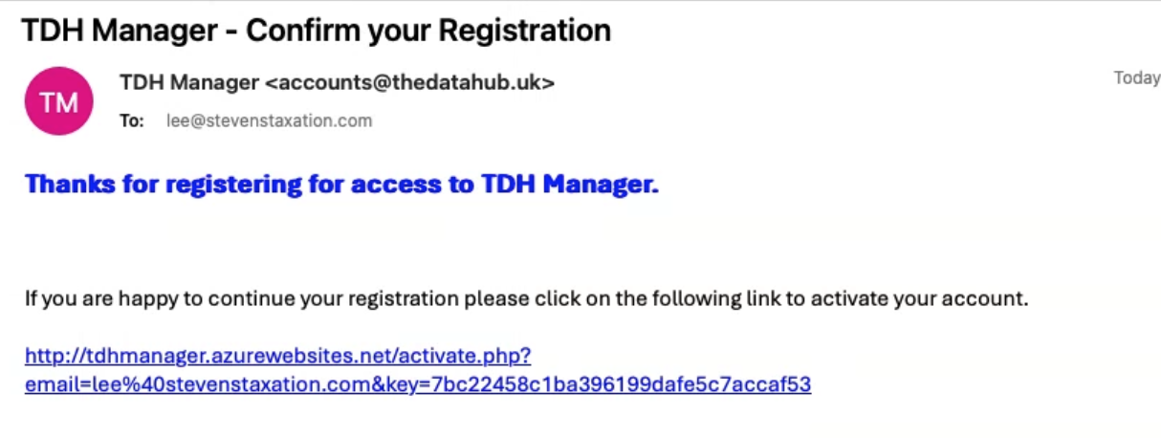

Account Activation

When the user clicks this link they will be redirected to activate.php and their email address and unique activation key will be checked. If all is OK, their account will be marked as activated and the process ends.

<?php
session_start();
include 'connect.php';
?>

<!DOCTYPE html>
<HTML lang='en'>
<HEAD>
<meta charset="utf-8">
<meta http-equiv="X-UA-Compatible" content="IE-edge">
<meta name = "viewport" content="width-device-width, initial-scale=1">
<title>Account Activation</title>
<link href="https://stackpath.bootstrapcdn.com/bootstrap/4.5.0/css/bootstrap.min.css" rel="stylesheet" integrity="sha384-9aIt2nRpC12Uk9gS9baDl411NQApFmC26EwAOH8WgZl5MYYxFfc+NcPb1dKGj7Sk" crossorigin="anonymous">
<style>
h1 {
color: purple;
}
.contactForm {
border: 1px solid mediumseagreen;
margin-top: 50px;
border-radius: 15px;
}
</style>

</HEAD>

<BODY>
<div class='container-fluid'>
<div class='row'>
<div class='col-sm offset-1 col-sm-10 contactForm'>
<h1 style='color: var(--navbarText)'>TDH Manager</h1>

<?php
// If email or activation key is missing then show an error
if (!isset($_GET['email']) || !isset($_GET['key'])) {
echo '<div class="alert alert-warning">There was an error registering your account, please click on the activation link you received by email</div>';
exit();
}
// Store them in two variables
$email = $_GET['email'];
$key = $_GET['key'];
// Prepare variables for query
$email = mysqli_real_escape_string($link, $email);
$key = mysqli_real_escape_string($link, $key);
// Run query - set activation field to activated for the email provided
$sql = "UPDATE tblUsers SET activation='activated' WHERE (email = '$email' AND activation ='$key') LIMIT 1";
$result = mysqli_query($link, $sql);
// If query is successful, show success message and invite user to login
if (mysqli_affected_rows($link) == 1) {
$sql = "SELECT userID FROM tblUsers WHERE (email='$email' AND activation='activated')";
$result = mysqli_query($link, $sql);
$row = mysqli_fetch_array($result);

echo '<div class="alert alert-success">Your account registration has been completed successfully</div>';
echo '<a href="index.php" type="button" class="btn-lg btn-success" style="margin-bottom: 10px;">Log In</a>';

$sql = "INSERT INTO tblEventLog (Description, UserID) VALUES ('New user has activated their account', '" . $row['userID'] . "')";
$result = mysqli_query($link, $sql);

} else {
// Show error message
echo '<div class="alert alert-danger">Your account could not be activated.</div>';
}
?>

</div>
</div>
</div>
</BODY>

</HTML>
This code checks to ensure the email address and activation key are present in the GET post, checks to ensure they match those stored in the database. If all is correct the ‘activation’ field in the user’s account is changed to activated a message is shown to the user and they are invited to log in. If an error is detected, then the user is informed and the process stopped.

